**Day 3 – E-Mail Service**

1. Research the following internet protocols related to e-mail services.
   1. SMTP Protocol
      1. Allows your PC to send mail
      2. Simple Mail Transfer Protocol
      3. It’s the protocol used when you hit “Send” to transfer your email message
      4. It’s also the protocol used behind the scenes to transfer your message from server to server as it makes its way to the server on which your recipient receives email
      5. It's also used for relaying or forwarding mail messages from one mail server to another
      6. The ability to relay messages from one server to another is necessary if the sender and recipient have different email service providers
   2. POP3 Protocol
      1. Allows your PC to read mail
      2. The language computers use to talk between themselves
      3. POP — the post office protocol — is the language used between a computer fetching email and the computer holding your email
      4. Thunderbird and Microsoft Office’s Outlook desktop program are two examples the “3”in POP3  indicates that we’re all using version three of the POP protocol
      5. Designed around the assumption that when you access your email, you want to download it to the computer you’re using
      6. So after your email program fetches email via POP3, that email resides only on your computer and nowhere else
      7. It’s best when you only read your email from a single location: your PC.
   3. IMAP Protocol
      1. IMAP is another protocol used by email programs to access your email.
      2. IMAP is an alternative to POP3, and works in a fundamentally different way. Those differences make it a frequently-preferred alternative in today’s always-connected world.
      3. IMAP assumes you want to leave the master copy of your email on the email server
      4. IMAP is simply a way of looking at that master copy from a connected device
      5. IMAP was designed with the goal of permitting complete management of an email box by multiple email clients
   4. Web Mail
      1. All mail stays on the server
      2. Server provides a dynamic web site that you access  
         through a web browser
      3. Web-based email, such as Outlook.com, Yahoo, and the like, displays the email directly from their servers to your web browser
      4. Uses SMTP behind the scenes to get and send email
      5. There’s no configuration needed other than logging in
2. Use the following resource as a starting point:  
   <https://askleo.com/what_is_pop_or_pop3_or_a_pop_account_and_what_about_smtp/>
3. Complete the following Venn Diagram to summarize your research.

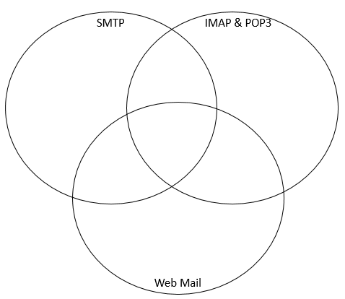

* Both deal with the email world
* All used to process emails
* They all need login

Web mail uses SMTP behind the radar to send and receive mail

* All mail stays on the server
* Sever provides a dynamic web site that you access through a web browser
* Simple mail transfer protocol - Allows your PC to send mail
* Lots of email companies use SMTP to follow through sending emails
* Allows your PC to read mail
* -POP3: Poat office Protocol